Lesson 2 Intro to Sensors

[1. Sebastian Introduction](https://classroom.udacity.com/nanodegrees/nd787/parts/a1505b23-c1aa-4bc6-a94c-d44d062d0209/modules/19b5af05-2ec7-491a-94db-1befc15d07c0/lessons/4d183789-b12c-462f-a134-9503d9216373/concepts/42a4c053-1a28-4662-bb0a-d29a38e8e7c9)

<https://www.youtube.com/watch?v=SeqO0Cti1Dw>

[2. Welcome Back](https://classroom.udacity.com/nanodegrees/nd787/parts/a1505b23-c1aa-4bc6-a94c-d44d062d0209/modules/19b5af05-2ec7-491a-94db-1befc15d07c0/lessons/4d183789-b12c-462f-a134-9503d9216373/concepts/15ba4fca-8ccf-4988-a5de-8366e8af6dbd)

<https://www.youtube.com/watch?v=bPvfjHJFF44>

[3. Introduction](https://classroom.udacity.com/nanodegrees/nd787/parts/a1505b23-c1aa-4bc6-a94c-d44d062d0209/modules/19b5af05-2ec7-491a-94db-1befc15d07c0/lessons/4d183789-b12c-462f-a134-9503d9216373/concepts/c2ffc83c-ad4e-4eb0-9b03-7a43bc436558)

<https://www.youtube.com/watch?v=ZeFXv7k2vaI>

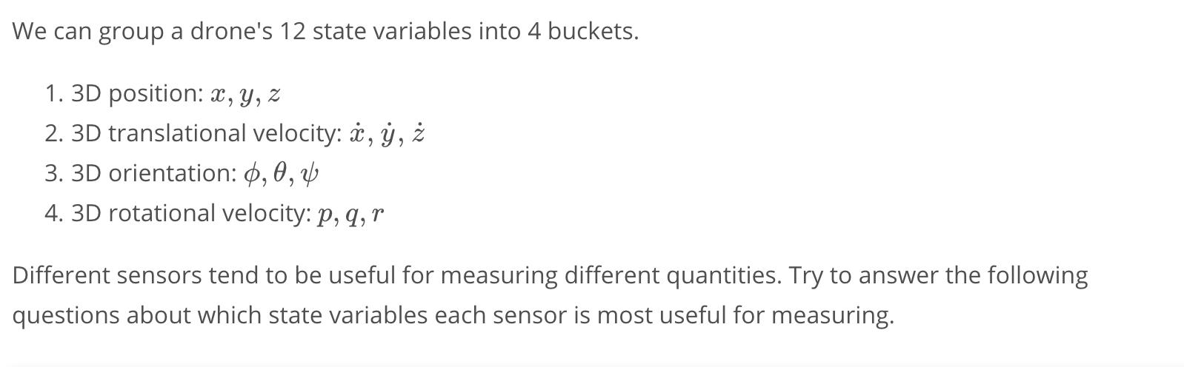

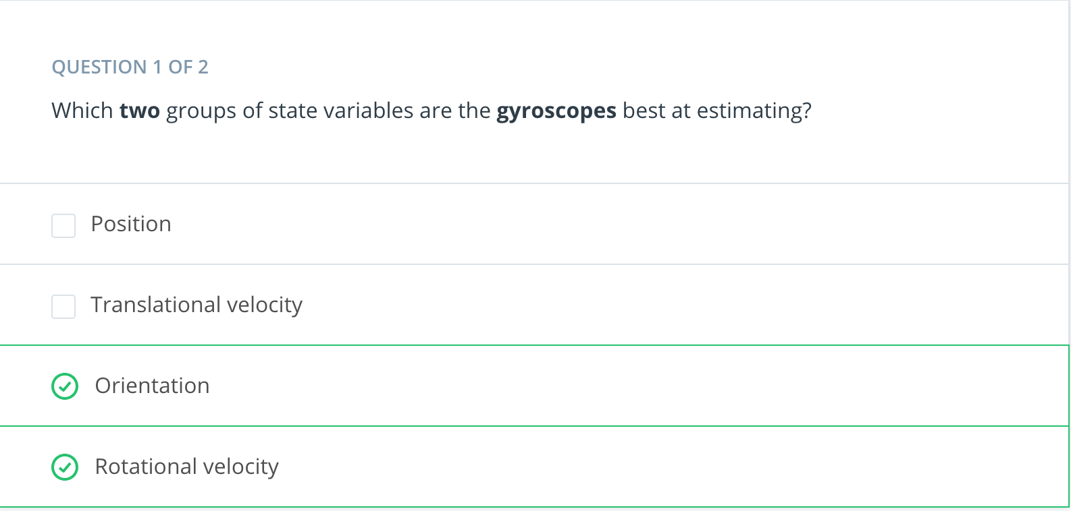

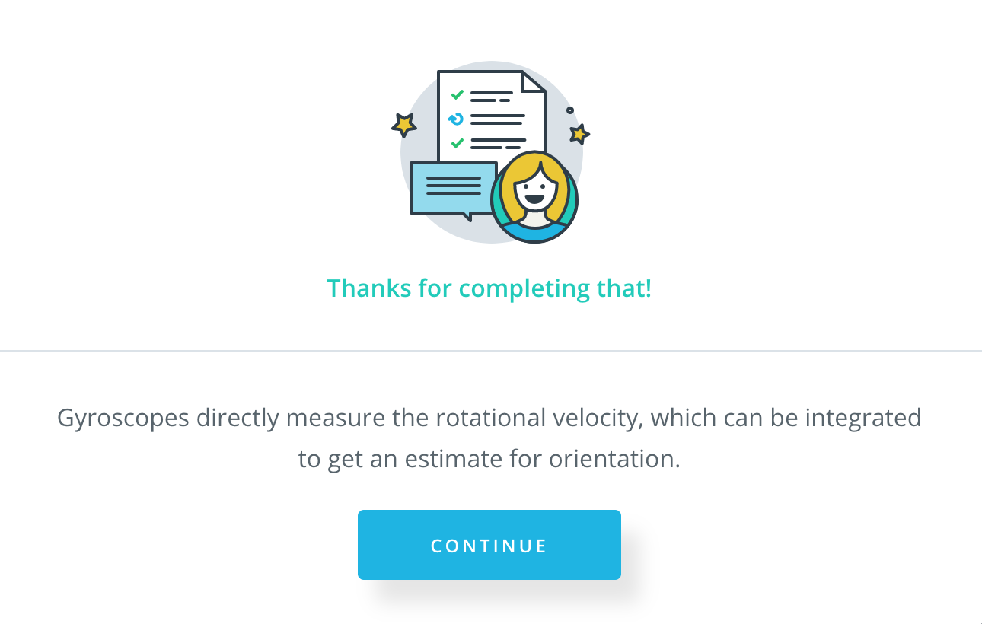

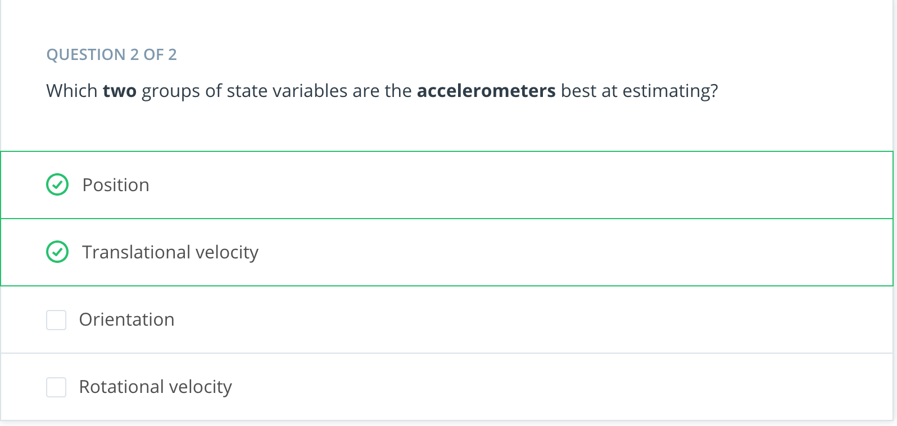

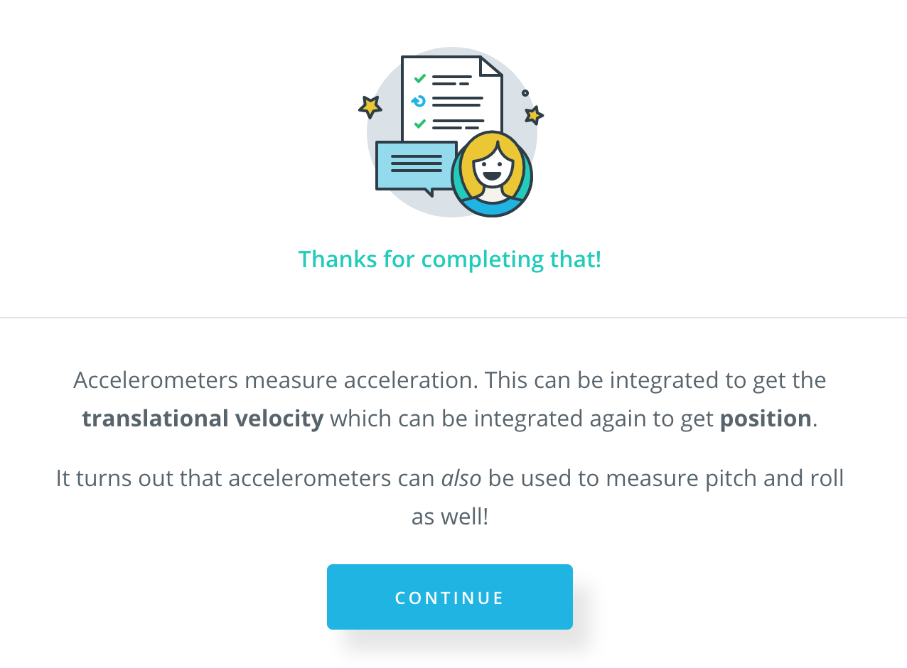

Take a look at the table below. This table will be discussed in the next video, but for now think about why it might be useful to have multiple measurements for certain quantities.

One reason is redundancy: if one sensor fails than another sensor is there for backup. But that's not the only reason! It's also important to consider *how* a sensor is inaccurate! Some sensors are noisy but unbiased. Some are biased but low-noise. Ideally we want our estimate of the vehicle's state to be both unbiased and low-noise and often that means using multiple sensors to measure the same quantity.

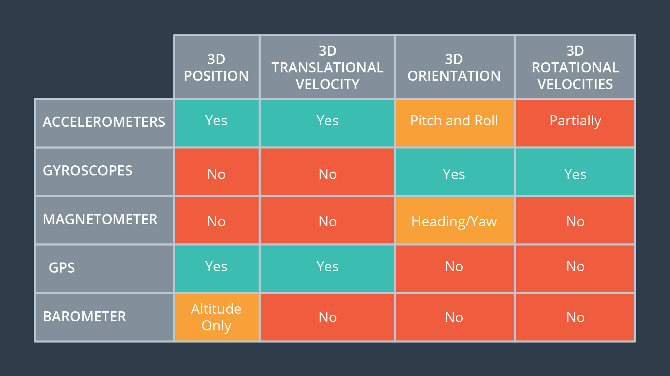

[4. Complementary Sensors](https://classroom.udacity.com/nanodegrees/nd787/parts/a1505b23-c1aa-4bc6-a94c-d44d062d0209/modules/19b5af05-2ec7-491a-94db-1befc15d07c0/lessons/4d183789-b12c-462f-a134-9503d9216373/concepts/a8474e51-7e48-4dd4-9826-57ab99d65a0a)

<https://www.youtube.com/watch?v=jhVT127kLGI>

[5. Inertial Sensors](https://classroom.udacity.com/nanodegrees/nd787/parts/a1505b23-c1aa-4bc6-a94c-d44d062d0209/modules/19b5af05-2ec7-491a-94db-1befc15d07c0/lessons/4d183789-b12c-462f-a134-9503d9216373/concepts/701626b0-5c58-4022-8aeb-e54e9210c781)  
<https://www.youtube.com/watch?v=50CBmWfDhKA>

[6. Rate Gyro Physics and Implementation](https://classroom.udacity.com/nanodegrees/nd787/parts/a1505b23-c1aa-4bc6-a94c-d44d062d0209/modules/19b5af05-2ec7-491a-94db-1befc15d07c0/lessons/4d183789-b12c-462f-a134-9503d9216373/concepts/73c788bc-8159-4b2f-8219-d9e77bf47594)

<https://www.youtube.com/watch?time_continue=2&v=MX_RKifV6T4>

[7. Gyro Measurement Model](https://classroom.udacity.com/nanodegrees/nd787/parts/a1505b23-c1aa-4bc6-a94c-d44d062d0209/modules/19b5af05-2ec7-491a-94db-1befc15d07c0/lessons/4d183789-b12c-462f-a134-9503d9216373/concepts/d7a12be1-1f00-47eb-9833-5ac95b5e30f3)

<https://www.youtube.com/watch?v=UnsHV0SR6So>

[8. Gyroscope Measurements](https://classroom.udacity.com/nanodegrees/nd787/parts/a1505b23-c1aa-4bc6-a94c-d44d062d0209/modules/19b5af05-2ec7-491a-94db-1befc15d07c0/lessons/4d183789-b12c-462f-a134-9503d9216373/concepts/9f7ce6c9-004f-4dc4-8f37-f3beb5860a53)

[Gyroscope_Measurements-Student.ipynb](https://view1ab1afda.udacity-student-workspaces.com/notebooks/Gyroscope_Measurements-Student.ipynb)

[9. Dead Reckoning Uncertainty](https://classroom.udacity.com/nanodegrees/nd787/parts/a1505b23-c1aa-4bc6-a94c-d44d062d0209/modules/19b5af05-2ec7-491a-94db-1befc15d07c0/lessons/4d183789-b12c-462f-a134-9503d9216373/concepts/b5ada6e4-41f7-4980-87de-34640629b44a)

<https://www.youtube.com/watch?v=IzoxlPFWIWU>

[10. Full 3D Attitude Update](https://classroom.udacity.com/nanodegrees/nd787/parts/a1505b23-c1aa-4bc6-a94c-d44d062d0209/modules/19b5af05-2ec7-491a-94db-1befc15d07c0/lessons/4d183789-b12c-462f-a134-9503d9216373/concepts/fffed472-7ffb-4b14-931e-b76dd05e8ce9)

<https://www.youtube.com/watch?v=MxofULgsyGE>

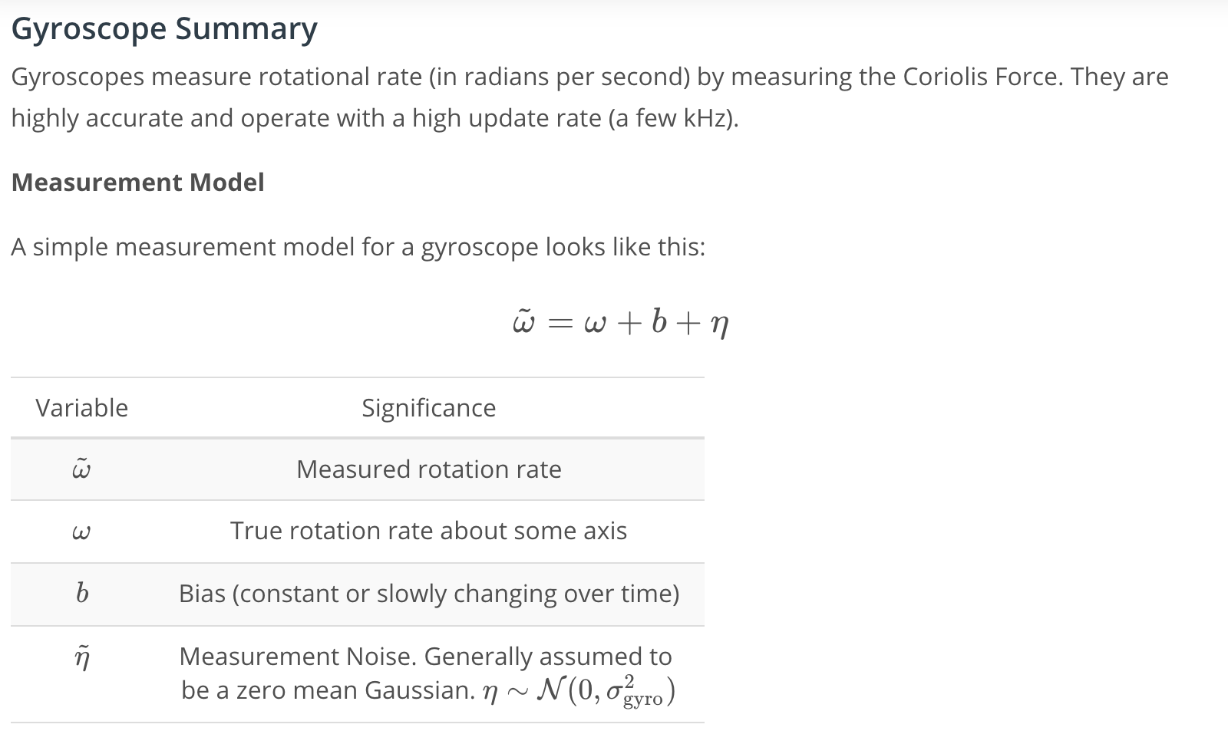

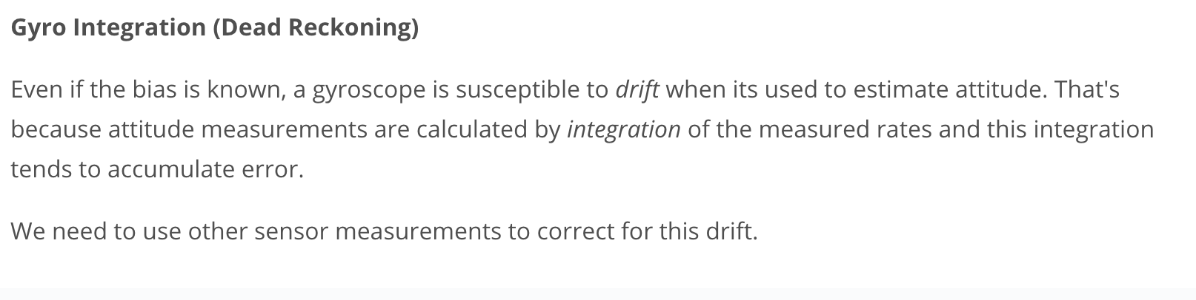

[11. Accelerometers](https://classroom.udacity.com/nanodegrees/nd787/parts/a1505b23-c1aa-4bc6-a94c-d44d062d0209/modules/19b5af05-2ec7-491a-94db-1befc15d07c0/lessons/4d183789-b12c-462f-a134-9503d9216373/concepts/331e90c0-ed8b-4b48-95e0-193a9f03d950)

<https://www.youtube.com/watch?v=g851qCxYr6k>

[12. Dead Reckoning 3D](https://classroom.udacity.com/nanodegrees/nd787/parts/a1505b23-c1aa-4bc6-a94c-d44d062d0209/modules/19b5af05-2ec7-491a-94db-1befc15d07c0/lessons/4d183789-b12c-462f-a134-9503d9216373/concepts/1a584896-3f75-4a52-88a9-6ae35e99d0c0)

[Dead_Reckoning_3D-Student.ipynb](https://view4073f318.udacity-student-workspaces.com/notebooks/Dead_Reckoning_3D-Student.ipynb)

[13. Two Things Accelerometers Measure](https://classroom.udacity.com/nanodegrees/nd787/parts/a1505b23-c1aa-4bc6-a94c-d44d062d0209/modules/19b5af05-2ec7-491a-94db-1befc15d07c0/lessons/4d183789-b12c-462f-a134-9503d9216373/concepts/94aab922-5762-4a3b-b9b6-9b63394c2f4b)

<https://www.youtube.com/watch?v=h5k8ayFvu58>

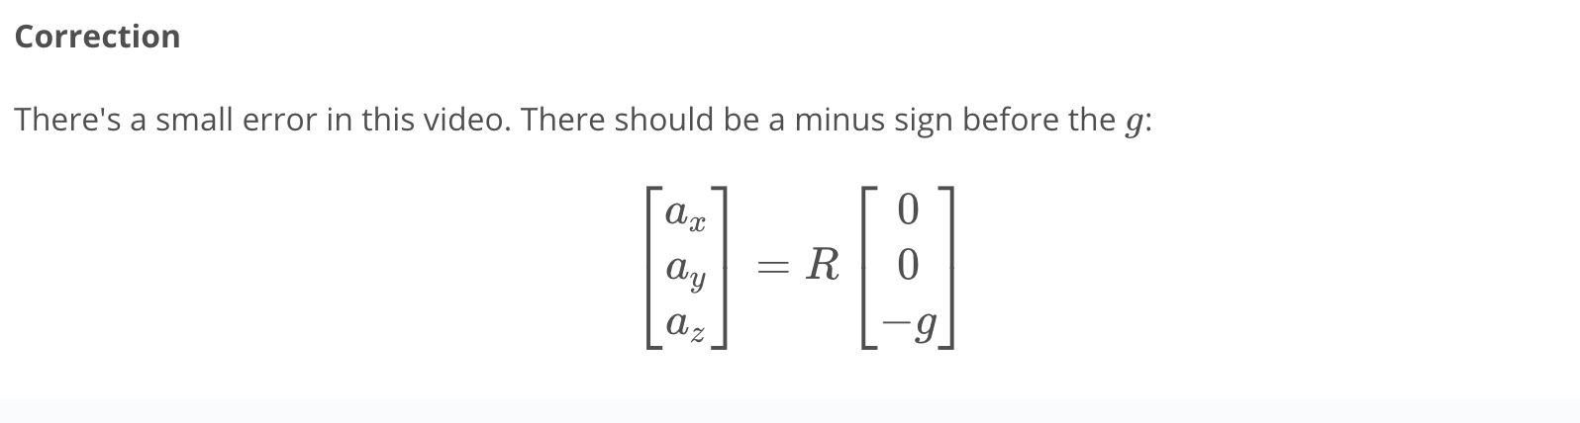

[14. Inertial Navigation vs Position Fixing](https://classroom.udacity.com/nanodegrees/nd787/parts/a1505b23-c1aa-4bc6-a94c-d44d062d0209/modules/19b5af05-2ec7-491a-94db-1befc15d07c0/lessons/4d183789-b12c-462f-a134-9503d9216373/concepts/5d41d21e-b653-41ec-a079-2e458f89549b)

<https://www.youtube.com/watch?v=irV_mAgx85k>

[15. Reading an IMU Spec Sheet](https://classroom.udacity.com/nanodegrees/nd787/parts/a1505b23-c1aa-4bc6-a94c-d44d062d0209/modules/19b5af05-2ec7-491a-94db-1befc15d07c0/lessons/4d183789-b12c-462f-a134-9503d9216373/concepts/0fded45c-d3e7-45cc-9f33-559b7c874a83)

<https://www.youtube.com/watch?time_continue=2&v=dTLjM-wxclo>

[16. Three Sources of Error](https://classroom.udacity.com/nanodegrees/nd787/parts/a1505b23-c1aa-4bc6-a94c-d44d062d0209/modules/19b5af05-2ec7-491a-94db-1befc15d07c0/lessons/4d183789-b12c-462f-a134-9503d9216373/concepts/2b70e7cf-8889-43cb-b4cb-d272108fa7a7)

<https://www.youtube.com/watch?v=NS_Kp-mPWb4>

[17. Calibration](https://classroom.udacity.com/nanodegrees/nd787/parts/a1505b23-c1aa-4bc6-a94c-d44d062d0209/modules/19b5af05-2ec7-491a-94db-1befc15d07c0/lessons/4d183789-b12c-462f-a134-9503d9216373/concepts/9894b04e-59c0-4e02-8e07-d2b910a57d30)

<https://www.youtube.com/watch?time_continue=3&v=mGoybWJ14wc>

[18. IMU Calibration](https://classroom.udacity.com/nanodegrees/nd787/parts/a1505b23-c1aa-4bc6-a94c-d44d062d0209/modules/19b5af05-2ec7-491a-94db-1befc15d07c0/lessons/4d183789-b12c-462f-a134-9503d9216373/concepts/aa91f958-65d5-4ed9-8891-2066dc2cf2f7)

[Calibration_in_3D-Student.ipynb](https://view74c17415.udacity-student-workspaces.com/notebooks/Calibration_in_3D-Student.ipynb)

[19. Magnetometer Intuition](https://classroom.udacity.com/nanodegrees/nd787/parts/a1505b23-c1aa-4bc6-a94c-d44d062d0209/modules/19b5af05-2ec7-491a-94db-1befc15d07c0/lessons/4d183789-b12c-462f-a134-9503d9216373/concepts/f67834be-0c7d-4842-8bd4-ec091fae0dcf)

<https://www.youtube.com/watch?time_continue=1&v=fnnwLDyi9kM>

### **Magnetometers and Magnetic Fields**

* The [Wikipedia article on Magnetometers](https://en.wikipedia.org/wiki/Magnetometer) and [the article on the magnetic fields](https://en.wikipedia.org/wiki/Magnetic_field) are a good place to begin if you want to learn more about these topics.

[20. Magnetometer Errors and Calibration](https://classroom.udacity.com/nanodegrees/nd787/parts/a1505b23-c1aa-4bc6-a94c-d44d062d0209/modules/19b5af05-2ec7-491a-94db-1befc15d07c0/lessons/4d183789-b12c-462f-a134-9503d9216373/concepts/dac9c453-b2d8-4ec3-8da0-d6cfc3abea9e)

<https://www.youtube.com/watch?v=Rp5bUAfnAiM>

## **Magnetometer Summary**

The magnetometer takes advantage of the fact that the Earth's magnetic field always has a northward component. When we know the roll and pitch of the vehicle we can use this fact to estimate the vehicle's absolute yaw angle relative to magnetic north.

Unlike gravity, the strength of the Earth's magnetic field is very weak and susceptible to distortions. For example, small electrical currents in wires onboard the drone can cause magnetic fields that overpower the Earth's magnetic field.

Distortions aren't the only problem either. The Earth's magnetic field varies in magnitude and declination depending on where on the globe you are.

Taken together, distortions and inconsistencies make the magnetometer measurements very noisy, but often they are the only source of absolute yaw information. We typically use magnetometers as a way to correct for drifting yaw measurements from the gyro.

[21. Magnetometer Calibration](https://classroom.udacity.com/nanodegrees/nd787/parts/a1505b23-c1aa-4bc6-a94c-d44d062d0209/modules/19b5af05-2ec7-491a-94db-1befc15d07c0/lessons/4d183789-b12c-462f-a134-9503d9216373/concepts/bf54acc7-8f05-4dd3-8b7a-45aa9e0e5445)

[Magnetometer_calibration-Student.ipynb](https://view4cec1868.udacity-student-workspaces.com/notebooks/Magnetometer_calibration-Student.ipynb)

[22. GPS Overview](https://classroom.udacity.com/nanodegrees/nd787/parts/a1505b23-c1aa-4bc6-a94c-d44d062d0209/modules/19b5af05-2ec7-491a-94db-1befc15d07c0/lessons/4d183789-b12c-462f-a134-9503d9216373/concepts/4d6d1682-38a9-4da8-a5d5-d2cef5f4ff58)

<https://www.youtube.com/watch?v=mXTNBI1DZAE>

[23. GPS Math](https://classroom.udacity.com/nanodegrees/nd787/parts/a1505b23-c1aa-4bc6-a94c-d44d062d0209/modules/19b5af05-2ec7-491a-94db-1befc15d07c0/lessons/4d183789-b12c-462f-a134-9503d9216373/concepts/d57e56b5-5f8f-4fa1-8337-a8776c6137bb)

<https://www.youtube.com/watch?time_continue=3&v=CzKi-xbSUGY>

[24. GPS Errors, Initialization, and Calibration](https://classroom.udacity.com/nanodegrees/nd787/parts/a1505b23-c1aa-4bc6-a94c-d44d062d0209/modules/19b5af05-2ec7-491a-94db-1befc15d07c0/lessons/4d183789-b12c-462f-a134-9503d9216373/concepts/6b4d7633-c68d-4bed-a083-df8bec96ee15)

<https://www.youtube.com/watch?v=lOzc32S3k6I>

## **GPS Summary**

GPS (Global Positioning System) is an amazing but complex system which provides unbiased but noisy measurements of absolute position. These measurements are used in conjunction with accelerometers (which are low noise but susceptible to drift) to infer vehicle position.

One of the truly remarkable properties of GPS is its infinite scalability. Since satellites only transmit information and don't have to receive any external data, one satellite can serve an unlimited number of GPS receivers.

#### **How it works**

A GPS receiver needs a line-of-sight to four GPS satellites. With this established, it can calculate the time of flight from each satellite to the receiver and then perform **trilateration** to infer its position. We can also use GPS to directly measure velocity by measuring Doppler shift.

Each time of flight measurement defines a "pseudorange" from the receiver to the corresponding satellite. In an ideal world, each "pseudorange" would be exact "range" from receiver to satellite. If this were the case, we would only need three satellites to localize a receiver on (or near) the surface of the Earth.

The fourth satellite is necessary to account for the "clock error" of the receiver.

#### **Sources of Errror**

Error is introduced anytime the signal from satellite to receiver is delayed. Light moves quickly and a delay of only 1 nanosecond corresponds to about 1 foot (30 cm) of error in calculated distance. There are a few ways that these errors tend occur:

1. Atmospheric Effects: electrons in the ionosphere can interfere with and delay the signal.
2. Multipath Errors: these occur when the satellite signal reflects off of some surface before reaching the receiver.

[25. The Barometer](https://classroom.udacity.com/nanodegrees/nd787/parts/a1505b23-c1aa-4bc6-a94c-d44d062d0209/modules/19b5af05-2ec7-491a-94db-1befc15d07c0/lessons/4d183789-b12c-462f-a134-9503d9216373/concepts/3cbfad1e-653e-406c-84d8-124c23619490)

<https://www.youtube.com/watch?time_continue=1&v=zSNNajfuqNg>

[26. Barometer Errors and Calibration](https://classroom.udacity.com/nanodegrees/nd787/parts/a1505b23-c1aa-4bc6-a94c-d44d062d0209/modules/19b5af05-2ec7-491a-94db-1befc15d07c0/lessons/4d183789-b12c-462f-a134-9503d9216373/concepts/4dea5761-e7fb-4f79-92af-08c20292b387)

<https://www.youtube.com/watch?v=XgYEMCUcBug>

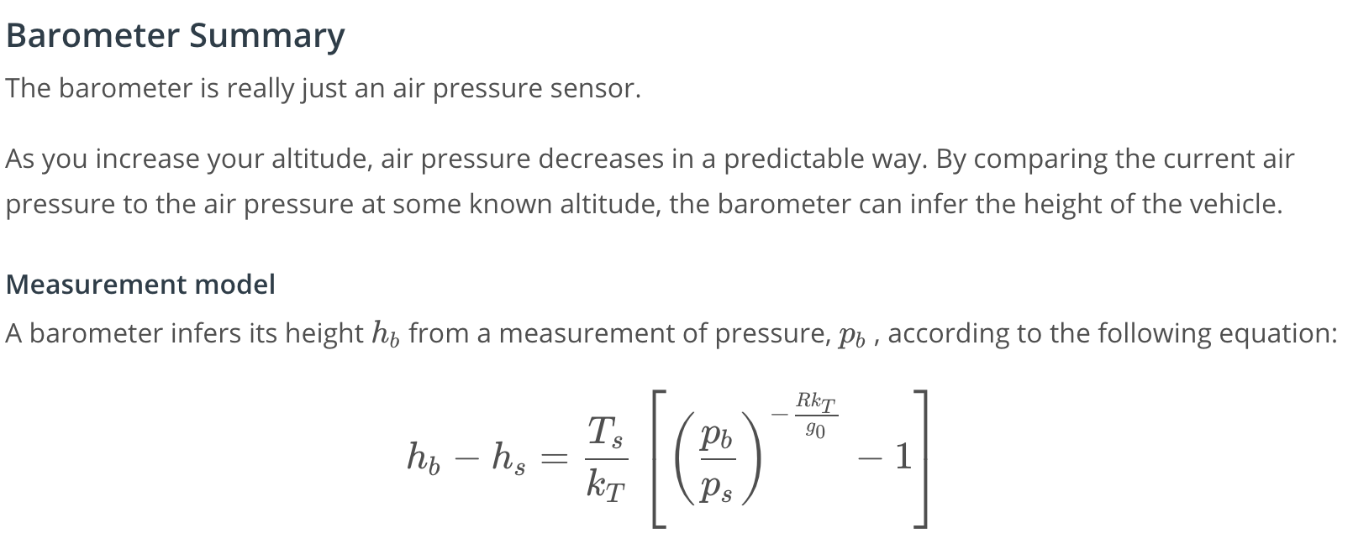

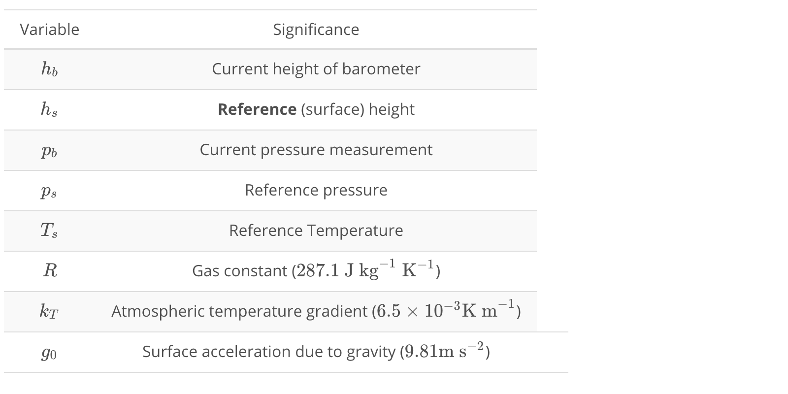

[27. Barometer and GPS integration](https://classroom.udacity.com/nanodegrees/nd787/parts/a1505b23-c1aa-4bc6-a94c-d44d062d0209/modules/19b5af05-2ec7-491a-94db-1befc15d07c0/lessons/4d183789-b12c-462f-a134-9503d9216373/concepts/fdcc613b-32a9-4063-bac8-d21bf7ffeeae)

[Barometer and GPS Integration - Student.ipynb](https://viewd3a09439.udacity-student-workspaces.com/notebooks/Barometer%20and%20GPS%20Integration%20-%20Student.ipynb)

[28. Summary](https://classroom.udacity.com/nanodegrees/nd787/parts/a1505b23-c1aa-4bc6-a94c-d44d062d0209/modules/19b5af05-2ec7-491a-94db-1befc15d07c0/lessons/4d183789-b12c-462f-a134-9503d9216373/concepts/808cfdcf-89fe-4de1-a65f-ee34c20d8d05)

<https://www.youtube.com/watch?v=lAYpXj-3s9k>